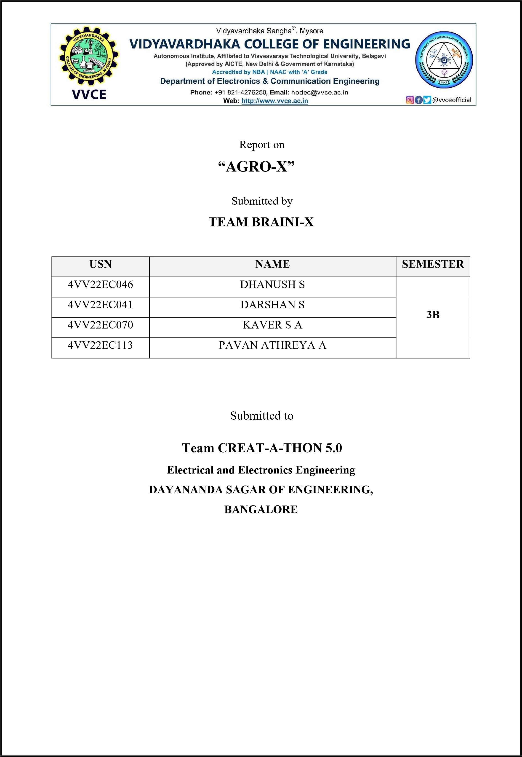

|  |  |  |
| --- | --- | --- |
|  | **Table of Contents** | **Page No.** |
| 1.1 | Abstract | 1 |
| 1.2 | Introduction | 2 |
| 1.3 | Problem Statement | 3 |
| 1.4 | Design | 4 |
| 1.5 | Working | 5 |
| 1.6 | Advantages | 6 |

**1.1 ABSTRACT**

**AGRO-X**

**Cultivating Life–Saving Animals**

Agro-X is an intelligent agricultural technology that aims to increase farmers’ crop growth. It incorporates a creative, non-lethal barrier system to scare away insects, animals, and pests and to alert property owners when it is triggered. The NPK soil quality sensor is one of the specialist sensors it employs to monitor the condition of the soil and identify intruders and wild animals in real-time. These sensors provide data to a central system, which uses preset criteria to evaluate the data and decide what’s going on in the fields or plantations. Farmers can then take prompt action to tend to their crops.

Because of this, farmers can raise more food with fewer resources.

**1.2 Introduction**

When wild animals intrude into rural regions, they have the potential to seriously harm both human life and property. Each year, farmlands and estates are invaded by animals, resulting in significant losses for farmers. In addition to devouring the crops, they also seriously harm them by stomping on them.

Wild animals have been known to destroy up to 50%–60% and even 100% of crops in some locations. According to data from the Union Ministry of Environment, Forests, and Climate Change in India, conflicts between humans and elephants were the primary cause of approximately 500 elephant deaths between 2014–2015 and 2018–2019. Also, 2,361 people died.

Plantations face threats from both pests and insects, causing physical harm by eating crops, spreading disease, and stunting growth. This harms crop health, reduces photosynthesis, and leads to nutrient loss, significantly lowering yields. Severe infestations raise pest management costs, affecting produce quality and causing losses. Pesticide use has long-term effects on biodiversity and can contaminate soil and water.

India loses Rs 5,000 crore worth of agricultural produce annually due to pests and rodents, with 18–25% overall productivity loss, totaling Rs 8,63,884 million each year.

Inadequate monitoring of soil properties, including temperature, moisture, phosphorus, potassium, and nitrogen, due to equipment shortages and inappropriate guidance, results in suboptimal nutrient levels. This negatively impacts crop health, lowering yields and compromising agricultural output. About 60% of Indian farmers lack access to proper soil testing, hindering well-informed judgments and impeding effective nutrient optimization and soil management.

As demand rises for agricultural products to support global population growth, there is a critical need for new solutions to protect crops. Plantations and farms are the foundation of a country’s economic stability. Therefore, it is crucial to protect these areas and the people who live there from these invasions while preventing animal harm.

**1.2 Problem Statement**

* **Incursion of Wild Animals into the rural landscapes, plantations, and agricultural areas:** The pressing issue involves wild animals encroaching into agricultural areas, disrupting rural life, and posing a threat to crops and livelihoods.This intrusion interferes with farming operations,upsetting the delicate balance of rural existence.Effective solutions are imperative for sustainable cohabitation and to mitigate the challenges posed by this encroachment.

* **Agricultural damage inflicted by insects and pests on farms and estates:**

Widespread agricultural damage from insects and pests seriously jeopardizes crop production and overall agricultural output on farms and estates.Effective pest management techniques are crucial for protecting crops, sustaining agricultural practices, and ensuring financial stability for farmers.

* **Inadequate soil monitoring equipment leads to the ineffective utilization of fertilizers and manure**:

Ineffective utilization of fertilizers and manure results from inadequate soil monitoring equipment, diminishing agricultural production. Farmers struggle to apply nutrients without reliable data, emphasizing the need for improved monitoring instruments to enhance crop output, soil health, and sustainable farming practices.

**1.2.1 Objective:**

This project aims to provide a novel and economical approach to reduce the influx of wild animals into farms or estates while guaranteeing the well-being of the animals. Uses of a non-lethal method to frighten out animals that enter the protected area. Create a simple UI or a website that contains all the data from day one.

**1.2.2 Uniqueness:**

We offer the owner a complete ecosystem, starting with a detection system and extending to deterrents, data storage, and soil quality sensors. Our system utilizes RF and thermal sensing,ensuring 24/7 automated detection and deterrents against animal intrusions from all directions through acoustic frequency generators and real-time wireless communication. Additionally, it deploys solar power, eliminating the need for wired grid connections, and providing versatile protection for farms of any size or terrain, along with real-time mobile or wireless device alerts.

**1.3 Design:**

**1.3.1 Wildlife Detection and Deterring System:**

* Our research has shown that animals are primarily scared of two things:

o High beam flickering floodlights o Specific acoustic frequencies.

* When the animals come in contact with high-beam flickering floodlights they get frightened and assume it as a sign of danger and discontinue their path.
* Coming to the frequency, every animal will have a certain audio frequency that they don’t want to hear or get irritated o For example: Elephants are such huge animals,but they get irritated by the buzzing noise created by the honey bees which come between 500-550hz.
* Surprisingly many animals also hate this range.
* Hence,we aim to detect the incoming animals,generate a frequency that affects that particular animal followed by the flickering lights,deter them,and wirelessly alert the owner through a handheld device and of course update the website about the intrusion for future interests.

**1.3.2 Pest Control:**

* Noise above 20 kHz or below 20 Hz may have variable effects on different birds, depending on their hearing abilities and sensitivities.
* But some pests may also be irritated by ultrasonic sounds above 20 kHz,which are inaudible o [For example,few studies have shown that ultrasonic devices can deter bats, rodents,and some insects,but have little or no effect at these frequencies on the birds.](https://www.birdbgone.com/blog/how-sound-bird-deterrents-work-to-scare-birds-away/)
* Therefore, we will be creating a low-power ultrasound frequency generator circuit that will emit thought and help to have better control over the pests and insects.

**1.3.3 Soil Quality Sensing and Updating:**

* A robot that moves across the corridors of the plantations through GPS navigation equipped with sensors capable of detecting pH,potassium,phosphorous,temperature,and moisture of the soil.
* All the data received will be sent remotely to the owner and will be updated and stored on the website with other necessary information that can be used for predictions in the future.

**1.4 Working:**

* This system uses two mechanisms, which function as two-step authentication, to validate the intrusion.
* At the edges of the fields and plantations, Doppler-effect-based radio frequency motion sensors will be deployed.
* It generates a low signal in the absence of movement;nevertheless, If the signal is blocked anywhere along the anticipated space, the system is triggered.
* With the aid of the stepper motor,the IR thermal sensor will begin to sense the field's temperature.
* Constantly, the values are fetched to the microcontroller.
* If the sensor comes into contact with a hot body, the difference between the object's temperature and the ambient temperature rises quickly,surpassing the pre-set threshold value.
* At this point, both the RF and thermal conditions come true.
* Thus, the microcontroller evaluates it as an intrusion and generates the frequency following the detected temperature.With frequency generation, the floodlights will also begin to flicker.
* The microcontroller wirelessly notifies the owner about the animal as soon as it detects an intrusion via a handheld device.
* This process will continue for X seconds,after which the thermal sensor will be fired again until it detects no movement for Y rotations.
* Ultimately,a switch can remotely turn the entire system on and off at the owner's end.
* A low-powered ultrasound frequency at a range of 40Khz will be designed,generated, amplified, and emitted continuously throughout the day.
* A mini robot will be built that is capable of moving autonomously through GPS navigation system equipped with an NPK sensor and goes to different predefined spots of the fields/plantations and tests the soil by lowering the sensor and the data is fetched.
* All the data that is read will be processed, analyzed,and displayed on the website with all the other useful data and the system will be capable of suggesting solutions and predicting crops best suited to that particular farmland.

**1.5 Advantages:**

* Animal-Friendly Barriers: In some cases, our design can be used to protect animals from harm.
* Garden Protection: This can be used to protect gardens from pests like deer, rabbits, and squirrels.
* Pest Control: In agricultural settings, our devices can be used to keep pests like raccoons, rodents, and insects away from crops and livestock feed.
* Home Security: our devices also serve as security measures. Motion-activated lights and alarms can startle both human intruders and wildlife from approaching a property.
* Livestock Protection: Farmers can use our product to protect their livestock from predators such as wolves, coyotes, tigers, and birds of prey.
* Public Spaces: In some urban areas these animal deterrents can used to discourage pigeons, seagulls, or other birds from gathering in public spaces.

* Plantations and farms are the foundation of a country's economic stability; thus, it is crucial to safeguard these crops and their keepers without seriously harming the animals.
* So, after installing this device, all the issues will be resolved.
* Farmers may purchase and install our complete ecosystem or particular systems based on their requirements since they are affordable and can be placed wherever they are needed.
* Neither the farmers nor the animals/insects/pests are damaged by this product.
* This leads to strong agricultural yields, which raises farmers' standards of living and helps to stabilize the economy of the nation.

❑ **Our mission is to make this ecosystem accessible and inexpensive to any farmer who is having this problem.**